**Experiment Number - 3**

**Student Name:** ANIKET KUMAR **UID:** 20BCS5306

**Branch:** CSE **Section/Group:** 20BCS_WM-703 / B

**Semester:** 5th **Date of Performance:** 06th Sep, 2022

**Subject Name:** DAA LAB **Subject Code:** 20CSP-312

**1. Aim/Overview of the practical:** Given an array which may contain duplicates, print all elements and their frequencies.

**2. Software Requirements:**

Visual Studio Code (IDE).

**3. Program Code:**

#include <iostream>

using namespace std;

int main()

{

int n;

cin >> n;

int arr[n];

for (int i = 0; i < n; i++)

{

cin >> arr[i];

}

int arr2[n];

int visit = -1;

for (int i = 0; i < n; i++)

{

int sum = 1;

for (int j = i + 1; j < n; j++)

{

if (arr[i] == arr[j])

{

sum++;

arr2[j] = visit;

}

}

if (arr2[i] != visit)

arr2[i] = sum;

}

for (int i = 0; i < n; i++)

{

if (arr2[i] != visit)

cout << arr[i] << " " << arr2[i] << endl;

}

}

**4. Output :**

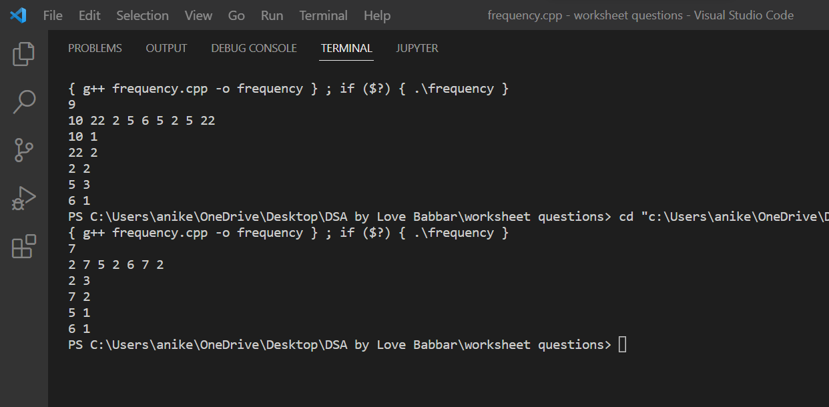

**Learning outcomes (What I have learnt):**

1. I have learnt how to write program in C++.
2. I have learnt about conditionals(if-else, switch-case) and loops(for loop, while loop, do-while loop).
3. I have learnt about arrays and strings.
4. I have learnt how to create functions in C++.
5. I have learnt about linked list, stacks, queues, etc.

**Evaluation Grid (To be created as per the SOP and Assessment guidelines by the faculty):**

|  |  |  |  |
| --- | --- | --- | --- |
| Sr. No. | Parameters | Marks Obtained | Maximum Marks |
| 1. |  |  |  |
| 2. |  |  |  |
| 3. |  |  |  |
|  |  |  |  |